Ayan Sarkar

University of denver

Project 1

**Project Approach:**

In this Database, I have used 7 tables in postgresql & 6 collections in MongoDB.

The extra table that I have implemented is: Customer Awards program; the customer gets 10 award points for every purchase. Every pizza costs $10 and completion time of 30 minutes.

Postgres Steps:-

CREATEDB BobsPizza;

psql BobsPizza;

\i /app/postgres/projects/project01/postgres/TableDropCommands.sql

\i /app/postgres/projects/project01/postgres/TableCreateCommands.sql

\i /app/postgres/projects/project01/postgres/LoadUsers.sql

\i /app/postgres/projects/project01/postgres/LoadCustomer.sql

\i /app/postgres/projects/project01/postgres/LoadInventory.sql

\i /app/postgres/projects/project01/postgres/LoadRecipe.sql

\i /app/postgres/projects/project01/postgres/LoadRecipeNeeds.sql

\i /app/postgres/projects/project01/postgres/LoadOrders.sql

\i /app/postgres/projects/project01/postgres/LoadCustomerAwardsProgram.sql

MongoDB Steps:-

mongo --host nosql-mongodb BobsPizza

use BobsPizza

load('/app/mongodb/projects/project01/mongo/CreateCollections.js')

load('/app/mongodb/projects/project01/mongo/LoadUsers.js')

load('/app/mongodb/projects/project01/mongo/LoadCustomer.js')

load('/app/mongodb/projects/project01/mongo/LoadInventory.js')

load('/app/mongodb/projects/project01/mongo/LoadRecipe.js')

load('/app/mongodb/projects/project01/mongo/LoadOrders.js')

load('/app/mongodb/projects/project01/mongo/LoadCustomerAwardsProgram.js')

The one thing which I found challenging while creating the databases in two DBs is that in Mongo , it is not clear as how to implement the foreign key functionality; I have implemented it through the use of “$ref” variable inside the collection insert statements.

**Index Performance Check in Postgres**

1. Before:

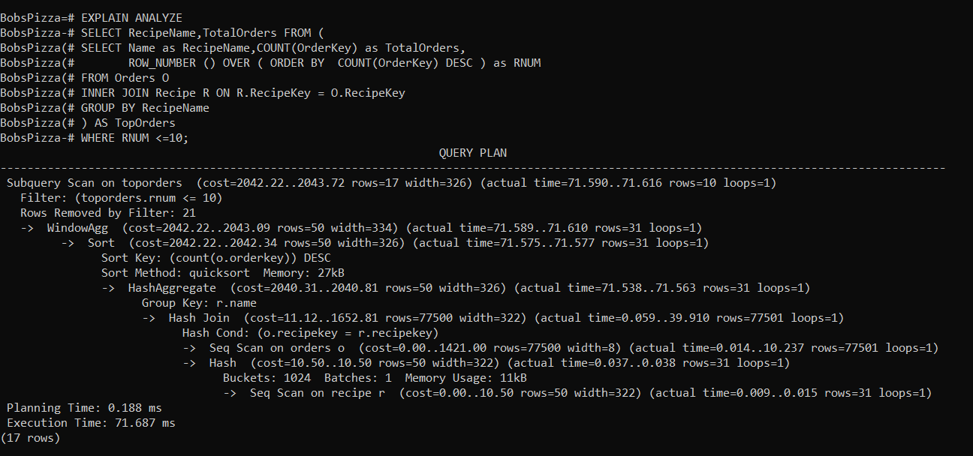

1. After

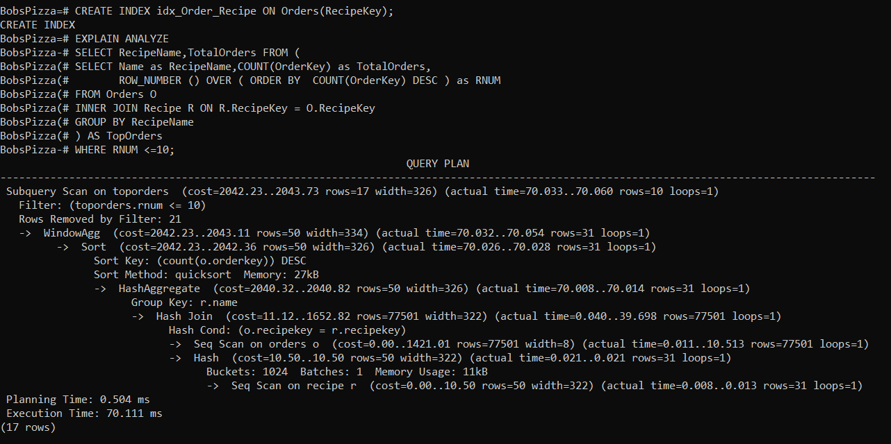

I noticed a drop in the execution time after implementation of index on Recipe Key.